Tech Features

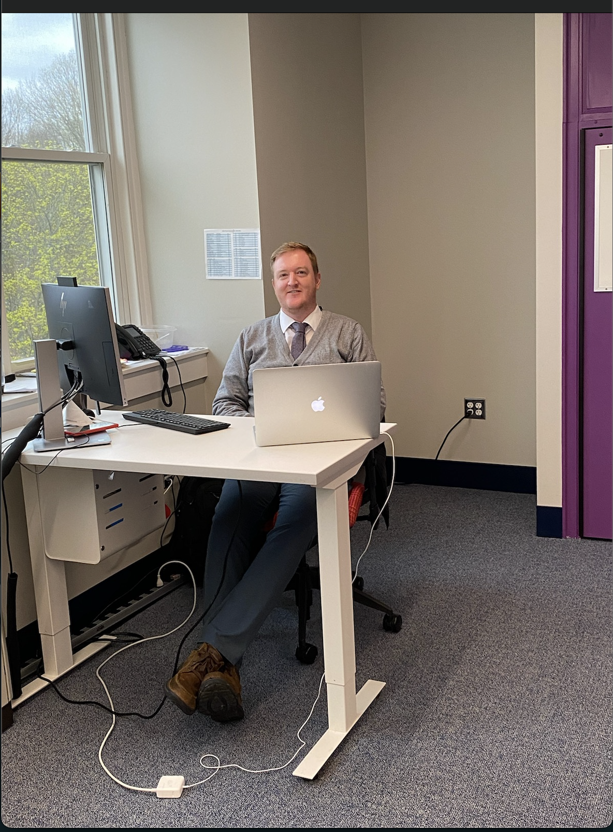

With the emergence of thousands of virtual platforms such as zoom, the pandemic has revolutionized technology all over the world. To learn how this trend impacted BISB, we sat down with computer science teacher, Mr. Glynn Johnson. He has been at BISB for 5 years and has been running the IT tech department as well. The IT department doesn’t just help you when your computer is having an issue; they provide help with hardware and implement advanced wifi systems that keep students and teachers online.

***How has this pandemic affected you?***

“Like everyone, the pandemic has brought challenges and changes to everyday life. Personally, one of the biggest challenges for me has been being unable to see family for over a year now. However, being back in school in person and seeing the vaccination rollout progress makes it really feel like brighter days are ahead and we are turning the corner.”

***How has the pandemic affected the implementation of technology in the new building?***

“The only thing that has been delayed is the purchasing of new computers for the brand-new Computer Science Lab.” We decided to hold off “[buying computers]” until we are ready to go so we can get the latest devices at the time. We had already invested in the Mac devices for the media suite and these are now in place. The biggest challenge was only using weekends and vacation times to have technicians on-site building the network, wireless internet, CCTV, etc.,” but it all came together nicely in time to launch the state-of-the-art facilities.”

***How has COVID19 affected the BISB technology department?***

“An element I am missing most is hands-on computing, using Raspberry Pis, 3d headsets, etc.,” but we have started to work on safe ways to get these back into the curriculum. I think Music and Science have done a great job of having individual equipment to continue in a safe way and I plan to learn from them.”

***Describe the adjustment made as a result of the Pandemic.***

“It was a very interesting switching basically overnight to Virtual School at the height of the pandemic but I can’t praise the students and staff enough for their resilience and taking it all in their stride. We really saw the advantages of being part of a global network of schools as our Asian schools had already learned the lessons and passed on advice and best practices by the time we went remote. The next challenge was blended learning and again we continue to reflect on ways to improve this all the time. It now feels like we are able to adapt to any changes and challenges as they present themselves.”

***What are your plans when the pandemic goes away?***

“I’ll revert back to physical computing tasks. Over the last five years, I have been implementing more robotics, hardware tasks, and hands-on experiences. I am really looking forward to continuing to develop this area. Next on the list is 3d game design which we can run on the latest VR headsets!”

We appreciate Mr. Johnson for his work around the clock with implementing all the new

technological systems into the Steam Center. His consistent effort with technology, keeps our school running at its very best each and every day.